Project Name:

Inspection & Test Plan
(ITP)

MCC Foundation – Concrete Works

Document Identification No.:

Rev. | Date | Description / Status | Prepared by | Verified by | Approved by

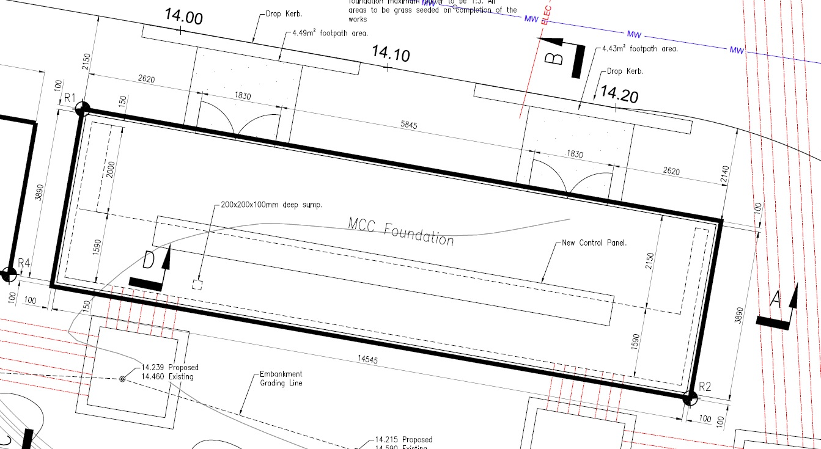
ITEM No. | DESCRIPTION | REFFERENCE DOCUMENT  (PROCEDURE / SPECIFICATION) | ACCEPTANCE  CRITERIA | TEST |  | RESPONSIBLE | SIGNATURES |  |  |  |  |  | RECORDS REQUIRED
 |  |  |  | METHOD | FREQUENCY |  | CONTRACTOR |  |  | CLIENT
 |  |  |  |  |  |  | Intervention | DATE | SIGN | Intervention | DATE | SIGN
1 | PRIOR TO CONSTRUCTION
1.1 | Detailed design drawing(s) reviewed and approved for construction | Drg XXXXXX. | Verified for construction drawing (latest version) | Review | Prior to works | Site Agent / Sub-agent | H |  |  | M |  |  | Copy of verified for construction drawing
1.2 | RAMS agreed with Client | Doc XXXXX | WI-402949-GEL-0010 \ WI 1110 | Review | Prior to works | Site Agent / Site Manager | H |  |  | A |  |  | Copy of approved RAMS
1.3 | Permit to Work or Access / Transfer Certificate obtained from Client | WI-402949-GEL-0010 \ WI 205 \ b | WI-402949-GEL-0010 \ WI 205 \ b | Review | Prior to works | Site Agent & PM | H |  |  | A |  |  | Copy or Permit to Work or Access / Transfer Certificate
1.4 | Ready-mix concrete supplier approved by Client | BS EN 8500-2 | CESWI 7 \ 2.22 Concrete ready-mix \ 1. | Review | Prior to works | Site Agent / Site Manager | H |  |  | A |  |  | Copy of valid UKAS accreditation certificates for product conformity from concrete producer.
1.5 | Structural concrete mix design(s) approval | BS EN 206-1,  BS 8500-1 | 5000004730-WW-DOC-00-19-0007 rev.0A/20.09.2019 \ 5.4 Concrete | Review | Prior to works | Site Agent / Site Manager | H |  |  | A |  |  | Copy of concrete mix design certificate(s) from concrete producer & evidence of approval.
1.6 | Initial testing of approved structural concrete (by concrete producer).  [*N/A in case of a prescribed concrete or a standardized prescribed concrete] | CESWI 7 \ Section 4 \ 4.2 Initial testing | BS EN 206-1: 2000 Clause 9.5, Clause 10 and Annex A | Compressive strength of concrete and consistence of concrete | For each classification of structural concrete | Concrete producer  /  Site Agent / Site Manager | H |  |  | R |  |  | Test certificates to be provided by the concrete producer.  Contractor is responsible for gathering required records.
1.7 | Steel reinforcement supplier approval | CESWI 7 \ 2.120 Steel Reinforcement | CESWI 7 \ 2.120 Steel Reinforcement | Review | Prior to works | Site Agent / Site Manager | H |  |  | A |  |  | Copy of valid certificates of approval for the manufacture and/or fabrication of steel reinforcement (CARES or equivalent) from reinforcement supplier.
2 | DURING CONSTRUCTION
2.1 | Excavation to correct line and level | Drg XXXXXX | Compliance with IFC (Issued for Construction) drawing(s) | Site check / visual | 100% | Site Manager | H |  |  | M |  |  | Field inspection checklist. Photographic evidence.
2.2 | Testing on the formation level underside of foundation (to identify any deformation or soft spots within footprint of the foundation) | 5000004730-WW-DOC-00-19-0007 rev.0A/20.09.2019 \ 6.11 Formation inspection | - >40kPa for cohesive material;  - SPT’N’>15 for granular material; | Hand vane test for cohesive soils;  DCP test (Dynamic Cone Penetrometer). | At a minimum of 5 m spacing along the footprint of the foundation | A suitably qualified person (Engineering Geologist / Geotechnical Engineer) | H |  |  | W |  |  | Field inspection checklist /3rd party certificate & Record of test results.
2.3 | Type 1 sub-base layer compacted until refusal at correct level and thickness | - Doc XXXXXX  - Drg XXXXXX  - CESWI 7 \ 2.55 Granular sub-base material. | - compliance with relevant drawing(s);  - material as per BS410-1 and BS 410-2. | 1.  site check / visual;  2. determination of particle size distribution as per BS EN 933-1. | Prior to concrete pour | 1.  Site Agent / Site Manager  2.  Material supplier | H |  |  | M |  |  | 1.  Field inspection checklist. Photographic evidence.  2.  PSD certificate (Particle Size Distribution) from material supplier.
2.4 | Concrete blinding poured at correct level and thickness | - Drg XXXXXX | compliance with relevant drawing(s) | Site check / visual | Prior to concrete pour | Site Manager | H |  |  | M |  |  | Field inspection checklist. Photographic evidence.
2.5 | Formwork at correct height, cover, alignment and sufficiently rigid and tight. | - Drg XXXXXX | - compliance with relevant drawing(s);  - CESWI 7 \ 4.10 Construction of formwork;  - BS 5975. | Site check / visual | Prior to concrete pour | Site Manager | H |  |  | M |  |  | Field inspection checklist. Photographic evidence.
2.6 | Ducting and structural voids positioned correctly | - Drg XXXXXX | - compliance with relevant drawing(s);  - CESWI 7 \ 4.10 Construction of formwork;  - BS 5975. | Site check / visual | Prior to concrete pour | Site Manager | H |  |  | M |  |  | Field inspection checklist. Photographic evidence.
2.7 | Steel reinforcement fabrications and shapes as per specifications | - Drg XXXXXX | - compliance with relevant structural drawing(s);  - CESWI 7 \ 2.120 Steel reinforcement;  - BS 8666. | Dimension inspection / visual | 100% | Site Manager | H |  |  | M |  |  | Field inspection checklist. Bending Schedule. Delivery ticket, Declaration of Performance (DOP) / CE marking from manufacturer. Photographic evidence.
2.8 | Fixing of steel reinforcement | - Drg XXXXXX | - compliance with relevant structural drawing(s);  - CESWI 7 \ 4.15 Fixing of reinforcement;  - BS 7973-2. | Dimension inspection / visual | 100% | Site Manager | H |  |  | M |  |  | Field inspection checklist. Photographic evidence.
2.9 | Concrete cover to reinforcement | - Drg XXXXXX | - compliance with relevant drawing(s);  - 5000004730-WW-DOC-00-19-0007 rev.0A/20.09.2019 \ 6.1 Concrete cover tolerance. | Dimension inspection / visual | 100% | Site Manager | H |  |  | M |  |  | Field inspection checklist. Photographic evidence.
2.8 | Concrete slump test and cubes sampled -performed at concrete receipt on site prior to pour (on structural concrete only). | - CESWI 7 \ 2.20.5 Concrete-General;  - CESWI 7 \ 2.22 Concrete Ready-Mix;  - CESWI 7 \ 4.3 Identity Testing;  - CESWI 7 \ 4.6 Concreting in cold weather;  - CESWI 7 \ 4.9 Records of Concreting. | BS 8500-1;  BS EN 206-1;  BS EN 12350-1;  BS EN 12350-2;  BS EN 12390-2;  BS EN 12390-3;  BS EN 12390-7. | Concrete slump test;  Concrete cube compression test. | 1 sample every 50m³ poured;  1 slump test / sample;  1 sample = 3 no. cubes tested @ 28days | Site Manager | H |  |  | W |  |  | Concrete delivery tickets. Certificates of concrete sampling & cube manufacturing. Concrete pour record. Concrete cube test certificates (from lab.)
2.9 | Removal of formwork.  Concrete curing and protection. | - Drg XXXXXX  - CESWI 7 \ 4.6 Concreting in cold weather;  - CESWI 7 \ 4.8 Curing;  - CESWI 7 \ 4.12 Striking of Formwork;  - 5000004730-WW-DOC-00-19-0007 rev.0A/20.09.2019 \ 6.2 Concrete curing period; | - compliance with relevant drawing(s);  - CESWI 7 \ 4.6 Concreting in cold weather;  - CESWI 7 \ 4.8 Curing;  - CESWI 7 \ 4.12 Striking of Formwork;  - 5000004730-WW-DOC-00-19-0007 rev.0A/20.09.2019 \ 6.2 Concrete curing period; | Dimension inspection.  Visual inspection. | 100% | Site Manager | W |  |  | M |  |  | Field inspection checklist. Photographic evidence.
2.10 | Concrete structure surface finish acceptable | - Drg XXXXXX  - CESWI 7 \ 4.21 Surface Finishes Produced Without Formwork;  - CESWI 7 \ 4.22 Surface Finishes Produced with Formwork;  - CESWI 7 \ 4.25 Tolerance for Concrete Surfaces;  - 5000004730-WW-DOC-00-19-0007 rev.0A/20.09.2019 \ 6.6 Exposed Edges. | - compliance with relevant drawing(s);  - CESWI 7 \ 4.21 Surface Finishes Produced Without Formwork;  - CESWI 7 \ 4.22 Surface Finishes Produced with Formwork;  - CESWI 7 \ 4.25 Tolerance for Concrete Surfaces;  - 5000004730-WW-DOC-00-19-0007 rev.0A/20.09.2019 \ 6.6 Exposed Edges. | Dimension inspection.  Visual inspection. | 100% | Site Manager | W |  |  | M |  |  | Field inspection checklist. Photographic evidence.
3 | POST CONSTRUCTION
3.1 | AS-BUILT drawings completed and submitted to client | - WI-402949-GEL-0010 \ WI 405 Completion definition;  - 5000004730-WW-DOC-00-19-0005 rev.0B/17.09.2019 \ 6.2 Information for the H&S File. | N/A | N/A | 100% | Designer.  Site Agent/Site Manager | H |  |  | R |  |  | AS-BUILT Drawings
3.2 | File all records to the Quality Folder on CDE | - Project PQP;  - Quality management systems. | N/A | N/A | 100% | Site Agent/Site Manager | D |  |  | - |  |  | All documents required by this ITP including signed-off ITP.

Note: Specify the type of intervention by putting one of the following letters in the Intervention column spaces:
D = To do | H = Hold point | A = Approval | R = Review | W = Witness | M = Monitor

ITP Completion Sign Off
Site Agent / Manager (on behalf of Contractor) | Project Manager (on behalf of Client)
Name: | Name:
Signature: | Signature:
Date: | Date:

